Dunton Bassett Parish Council


H Denton-Stacey, Clerk to the Council
Proper Officer,PO Box 11198, Lutterworth,LE17 9FX
07734793986
clerk@duntonbassettparishcouncil.org.uk

Councillors are summoned to attend the Annual Parish meeting of DUNTON BASSETT PARISH COUNCIL to be held in the Village Hall, Dunton Bassett on Tuesday 12th November 2024 at 7.15 pm.
Members of the public and press are cordially invited to attend.
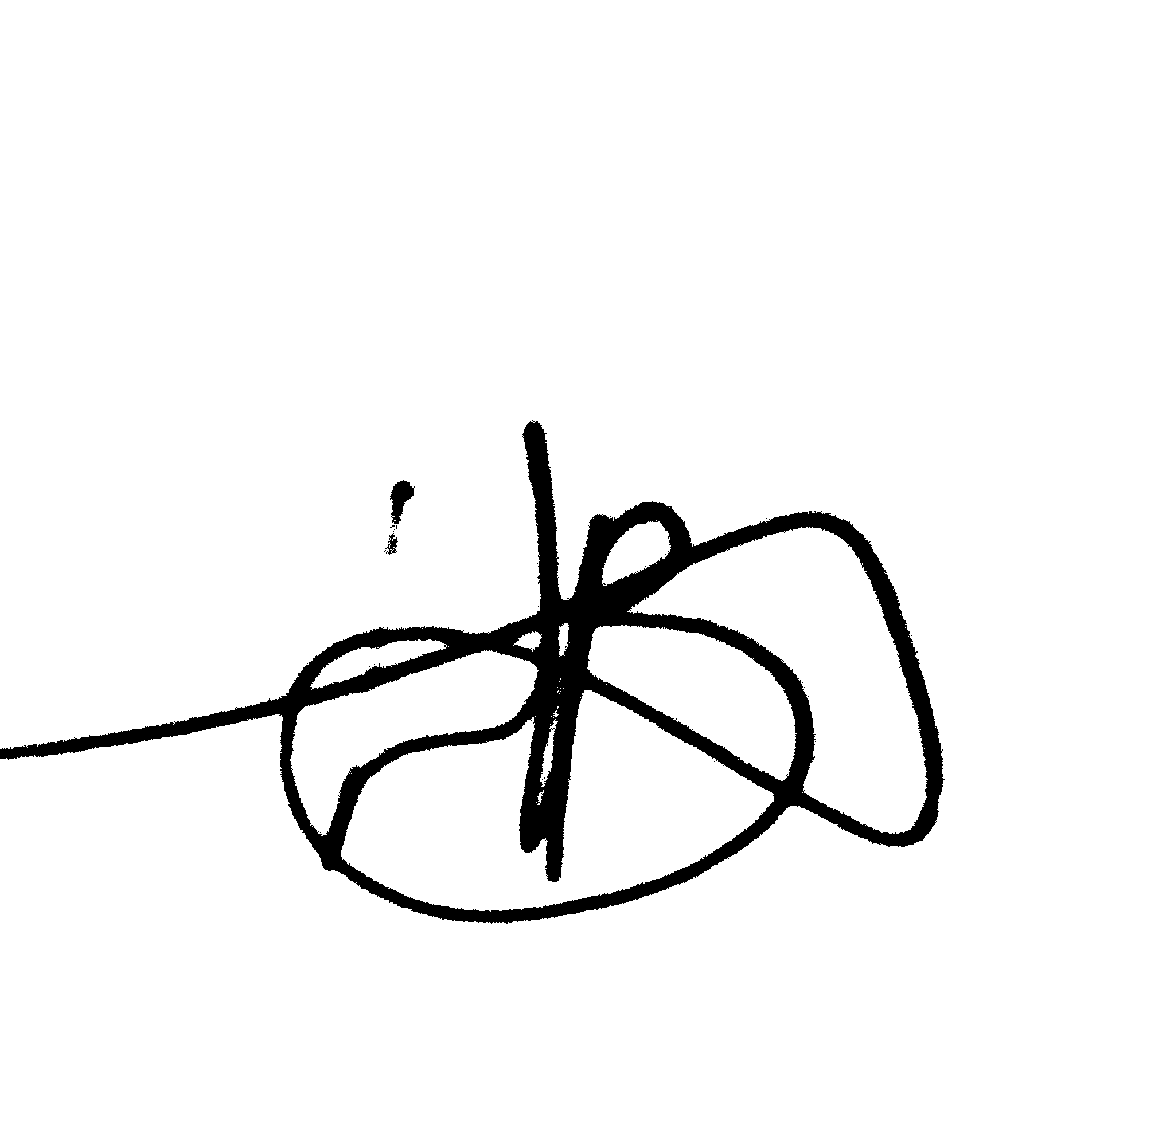
Helen Denton-Stacey
Clerk to the Council
30th October 2024
AGENDA

1 | Apologies for absence
2 | Declarations of Interest and Requests for Dispensations
3  4 | To sign as an accurate record the minutes of the previous meetings: Tuesday 8th October 2024  Matters Arising
5 | Meeting open to the public
6 | Reports:  (a) County Councillor for the Broughton Division  (b) District Councillor for the Dunton Ward  (c) Police  (d) Clerks report to council
7 | Planning Applications and Decisions for Consideration
8 | To receive a report and recommendations from the Windfarm Working Party
9 | To receive a report and recommendations from the Playground Working Party
10  11 | Highway issues/ Footpaths  Community Grant
12 | Vas
13 | Finance & Accounts:  (a) To note the financial situation as at 31st October 2024 (to be tabled at the meeting)  (b) To approve accounts for payment  H Denton-Stacey Clerks Salary Nov As per contract  HMRC Employee Tax Nov As per contract  H Denton-Stacey Phone Nov £12.66  H Denton-Stacey Clerks expenses Nov £23.04  Leicestershire Gardens £440.00  RBL Poppy wreath £24.99
14  15  16 | Late items for discussion  Correspondence  Items for discussion at the next meeting
17 | Date of Next Meeting: Tuesday 10th December 2024.

